**Project Design Phase-II**

**Data Flow Diagram & User Stories**

|  |  |
| --- | --- |
| Date | 31 January 2025 |
| Team ID | LTVIP2025TMID35471 |
| Project Name | Smart Sorting: Transfer Learning for Identifying Rotten Fruits and Vegetables |
| Maximum Marks | 4 Marks |

**Data Flow Diagrams:**

A Data Flow Diagram (DFD) is a traditional visual representation of the information flows within a system. A neat and clear DFD can depict the right amount of the system requirement graphically. It shows how data enters and leaves the system, what changes the information, and where data is stored.

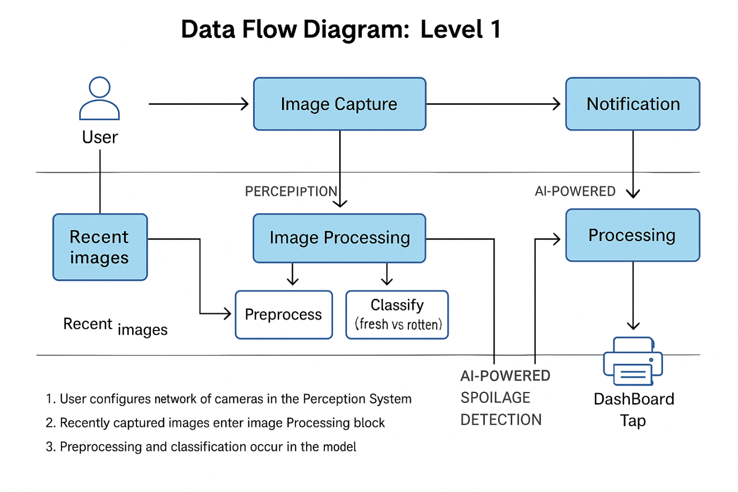

**User Stories**

